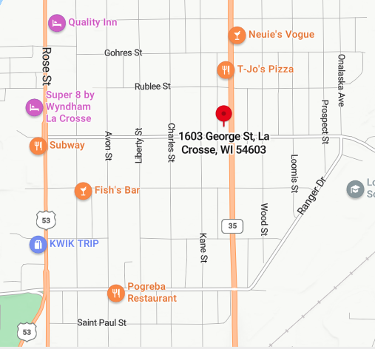
1603 George St.
La Crosse, WI 54603
https://waferlacrosse.org/
Phone: 608.782.6003
Fax: 608.782.6006
Erin Waldhart
Executive Director
waferdirector@waferlacrosse.org
Volunteer Hours:
Monday-Friday
8:30 Am – 12:45 pm
Monday, Tuesday, Thursday
3:30 pm – 7:45 pm

We look forward to working with you, and appreciate your commitment to serving the community!
Contact us

Welcome!
WAFER food pantry welcomes you as a new partner in providing food to people in need and eliminating hunger. WAFER is the largest food pantry serving all of La Crosse County.
- We serve about 1,500 families (about 4,000 people) monthly. Nearly 35,000 total individuals were served in 2025.
- WAFER distributes about 17,000 food packages a year.
- In 2027, 1.6 million pounds, equivalent to 1.3+ million meals, were given out.

As a volunteer, you will play a crucial role in serving community members who need it the most while developing team-building skills. Volunteers at WAFER contribute in the following areas:
- Warehouse: Stocking, sorting, and organizing food
- Pantry: Putting together food packages for distribution
- Distribution: Hand out food packages to patrons
- Mobile pantry: Join Tony on the bus in putting together food packages and distributing them at various locations throughout the community
- Leading programs: Join us in leading monthly free programs here at the facility. Topics range from cooking to budgeting to social services and more
- Special events: Represent WAFER at community events to provide general information, volunteer recruitment, and collect donations

Your Next Steps:
- Schedule your first shift over the phone or email. Our volunteer hours are to the right, with the highest need being evenings. We welcome partial shifts to fit busy schedules— just let us know what time you’ll be here.

Your First Day:
  - Wear comfortable clothes free from drug/alcohol references or profanity. Closed-toe shoes are required.
  - We have free parking in the lot next to the building.
  - When you arrive, come in through the front door for morning shift, or side door (around the back) for evening shift. We will show you where to sign in and review some brief paperwork. You will be given a tour of the building and introduced to your team members.
  - We provide refreshments and snacks to all volunteers, but feel free to bring a water bottle if you’d like.

