

*Thank you for choosing to host a food or fund drive to support individuals and families in local communities. Your efforts impact your neighbors in need. Your donations will be used for families and individuals throughout La Crosse County. Please contact WAFER staff regarding your food or fund drive if you would like assistance with ideas, logistics, containers, advertising, appropriate logo files, and more.*

Food and Fund Drive Kit

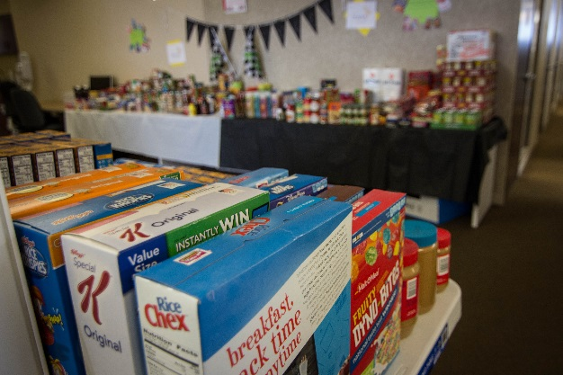  
Planning a food/fund drive for WAFER is easier than you may think. Hosting a drive strengthens the community by providing basic necessities for people in need and cultivates a sense of purpose when people work together for a common goal. Each year, hundreds of local businesses, organizations, schools, clubs, churches, and more host a food/fund drive to benefit their neighbors in need and those served by WAFER.   
  
All food and funds given to WAFER directly benefit people throughout La Crosse County.

Your efforts can make a huge impact in the amount and variety of foods available to food pantry patrons. Even a small group can make a big difference.  
  
  
For every $1 donated, WAFER is able to provide 4 meals.

Getting started

Facts:

Each month, WAFER provides ~1500 food packages containing enough food to feed each person in the households for 4-5 days.

In 2023, WAFER provided 1.5+ million meals through in-house distribution and outreach programs.

According to Feeding America, 1 in 10 are food insecure. Feeding Wisconsin research found 1 in 5 children are food insecure, yet 1 in 4 of the people benefitting from food from WAFER is under the age of 18.

According to Great Rivers United Way ALICE Report, approximately 50% of City of La Crosse families do not have enough income to provide for basic necessities and are forced to make choices between them. Choices can include food vs medical care, medications, rent, utilities, etc.

Organization – Successful food drives have an enthusiastic team or leader organizing, raising awareness, encouraging participation, and spreading the word. Determine a start and end date, the method and location for the collections, whether you need crates from the food pantry or you have or will create your own, and whether you will be dropping off the donation or will need to request a pick up.

Set your goal – This is a great way to encourage teamwork and provide a sense of accomplishment when it is achieved. The goal may be a monetary amount, a food pound goal, an item count, or one/all of these. Make the goal realistic and clear for all drive participants.

Promote it – Make the drive fun and creative by incorporating competitions, rewards, incentives, theme days, and more. Create flyers to advertise the event and post them in public areas, through in-house email, post the event on social media, notify your customers, put it on your website, contact your local media outlets, etc. Keep drive participants up to date with progress and push through to the end.

Share your success – take pictures and share those with us (info@waferlacrosse.org), send us the link to your social media or internet information, or invite us to speak to drive participants.

**Questions?**

**Contact Erin Waldhart at:  
 608-782-6003, x5 or  
 waferdirector@waferlacrosse.org**

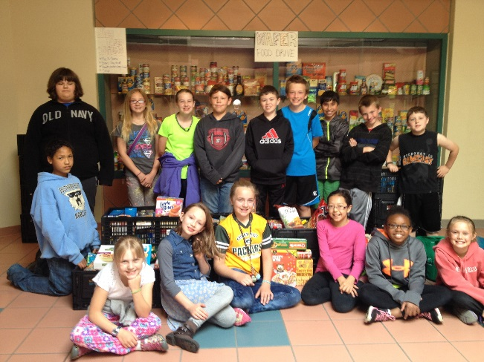

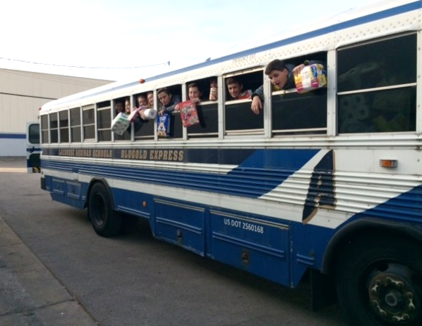

Creative ideas

* + Choose a catchy name or theme for your food drive.
  + Create a display board to show hunger statistics, track progess, etc.
  + Create challenges between department, classes, clubs, etc. The winner could receive a pizza or popcorn party, special parking spot, casual dress day, or a traveling trophy.
  + Schedule a kick-off fund event to create interest in the food drive. This could be an office party or event that requires a food item for admission.
  + Have food assigned to a particular day of the week: Macaroni Monday, Tuna Tuesday.
  + Pick one food item only to collect, and collect, and collect……
  + Use the collected food to build a fun display (see Christmas display from 501 Main St Businesses below).

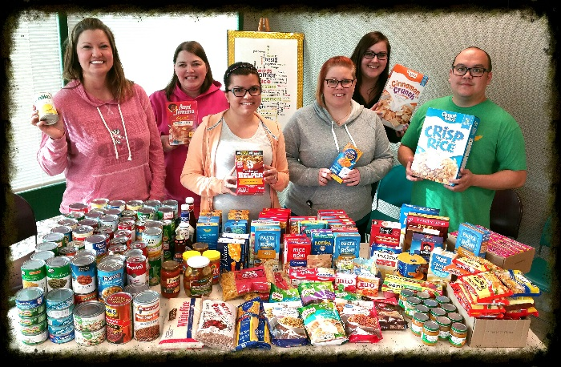

**Most Needed Items**

While we strive to offer a variety of nutritionally balanced food items and foods important to seniors, children, and diverse cultures, our most needed items are:

Meats/Proteins  
Canned tuna, chicken, salmon, peanut butter, and beans (dried or canned)

Canned Soups

Mac-n-Cheese

Canned or dried fruit

Side dishes  
Pasta/rice packets, boxed meals, boxed potatoes, stuffing, canned potatoes, rice

Special Dietary Foods  
Low-sugar, low-sodium, gluten free

Personal Care Products  
Shampoo, deodorant, soaps, toothbrush, toothpaste, razors, baby products, and feminine hygiene items.

Resources available:  
 Electronic logo for your marketing materials  
 Collection barrels (large or small) or collapsable crates  
 Sturdy “Thank you for donating” sign, 2’x3’  
 WAFER literature (brochures, newsletters)  
 Flyer (see below)  
 Request staff to speak to drive participants

Questions? Contact:  
 Erin Waldhart, Executive Director  
 608-782-6003, x5  
 waferdirector@waferlacrosse.org

Drop off your donations at:  
 WAFER Food Pantry  
 1603 George St, La Crosse, WI 54603  
 Hours: M-F 8am-12:30pm and M, T, Th 4pm-7pm  
 *Pick up of large collections may be available.

*Consider including a financial gift as part of a food drive. Cash gifts allow WAFER to purchase items not received in donations to ensure that each household has a complete food package for every request.* 

***For every $1 donated WAFER can purchase 4 meals.***

*Monetary donations can be mailed or dropped off and online donations can be made at waferlacrosse.org.*

