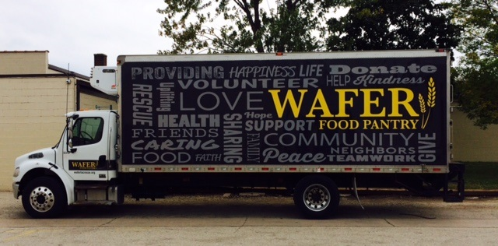Part-time Job Opportunity,   
Join Our Team

Driver

The Driver will primarily pick up/deliver food on established routes, with schedules that vary day-to-day. In addition to driving routes, this position requires warehouse work such as receiving, weighing, sorting, stocking, and storing product, and strong interpersonal communication and customer service skills to build/maintain positive donor relations.

Qualifications:

1. Strong attendance record
2. Education level of at least High School Diploma/GED
3. Current Driver’s license with accident free record in the previous two years.
4. Ability to pass the DOT exam, including drug testing.
5. Prefer experience driving a large cargo van and large box truck.
6. The ability to frequently stoop and lift 50+ pounds.
7. Basic math skills; fractions, decimals, percentages.

Schedule: Varies, flexible. Monday through Friday 8:00 to 1:00, occasional weekends, evenings, or events as needed. This position will be approximately 3-4 days per week. Starting pay $14-$16/hour.

The business offers 401k match and paid time off after 1 year of service. Insurance is not offered.

Applications: Download from waferlacrosse.org OR apply via the Indeed job posting.